## 1. Current-Voltage (I-V) Characteristics

* I-V characteristic defines the relationship between the **current flow (through), I** and **voltage (across), V** an electronic device or element.
* A tool for understanding the operation of the circuit.
* The Current-Voltage (I-V) characteristics are found by evaluating the **response** of a device/element under different conditions. The behavior of a device depends on the **applied excitation** and can change if the excitation changes. For example, a device may act as an “open circuit” under certain input conditions and as “current source” in another. A diode acts as an open circuit below a specific threshold voltage and acts differently after that.

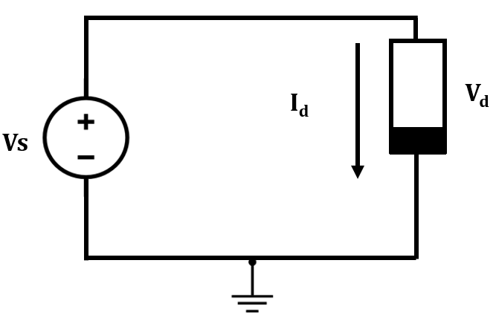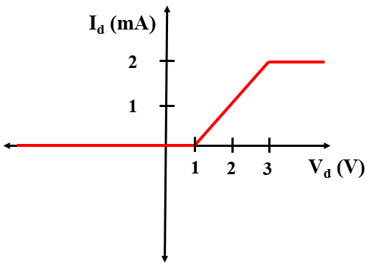

**(a) (b)**

**Figure 1: (a) A circuit with a voltage source, (b) I-V characteristic of the device**

A simple circuit with a voltage source and an electronic device is shown in Figure 1(a). The voltage source acts as an excitation medium for the device. Varying the voltage source would result in change in the current flow, Id across the device. By plotting this current with respect to the voltage across the device, Vd, the I-V characteristics of this device can be determined. From the I-V characteristic graph, it can be seen that no current flows through the device below 1 V which indicates that it acts as an open circuit in this region. After that, the behavior changes and between 1 V-3 V, the current through this device increases linearly. After 3 V it is fixed at 2 mA.

## **Linear and Nonlinear Devices/Elements**

* Depending on the I-V characteristics, the electronic devices/ elements can be divided into two categories:

1. **Linear Devices/Elements:** The Current-Voltage relationship is linear i.e. the current through the element is a linear function of the applied voltage across it. The relationship can be characterized by:

$I=kV$

Where k is a constant. The I-V graph for these elements may look like this:

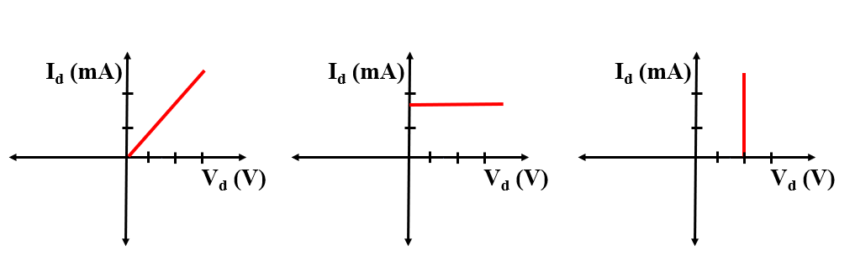

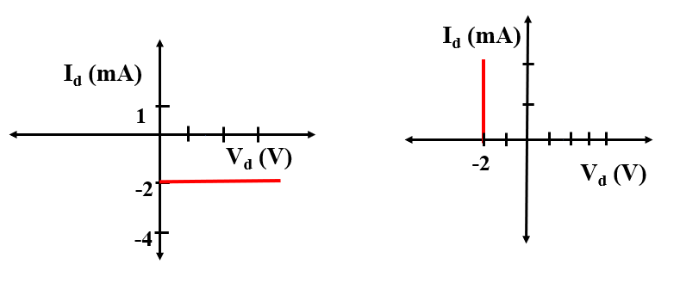

**Figure 2: I-V curves of some linear elements**

It is seen that the currents through the elements change linearly with varying voltage. An important point to note is that the “slope” of any given curve is a constant. For example, in **curve 1**, the slope is “2” at any point of the curve. The slope can be found out by the following equation:

**Slope, |m|=**

Some examples of linear elements are **resistors, current source, voltage source** etc.

1. **Non-Linear Devices/Elements:** The Current-Voltage relationship is Non-linear i.e. the current through the element is a **nonlinear** function of the applied voltage across it.

$I=\sqrt{V}$

$I=V^{2}$

$I=V^{-3}$ and so on

The I-V graph for Non-linear elements may look like this:

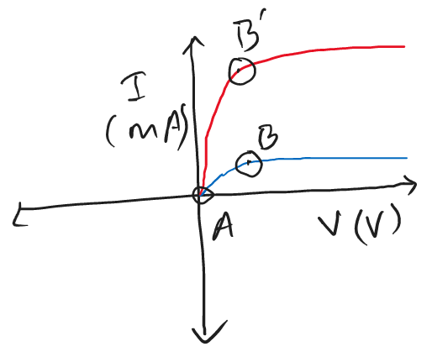

**Figure 3: I-V curves of some non-linear devices/elements**

It is seen that the currents through the elements change non-linearly with varying voltage. This means that the “slope” of any given curve here is not constant. For example, in **curves 1 and 2**, the slope at point “A” and “B/B’” are different. The change in the current flow is not constant here. In some regions, the change in current may be very high for a small change in the voltage. In these cases, the slope will be high and the curve will look steeper. On the other hand, in some regions the change in current may be very low and so the slope will be lower. For example, in **curve 1,** the slope is very low in region **“AB”** whereas it is high for **“AB”** is true for **curve 2**.

Some examples of non-linear elements are **Diodes, Metal Oxide Field Effect Transistors (MOSFETs), Bi-polar Junction Transistors (BJTs)** etc.

### **Practice Problems**

* Identify which of these I-V curves are Linear and which are Nonlinear:

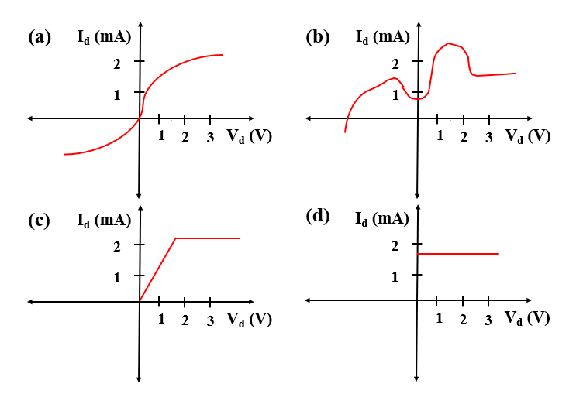

**Ans: Linear: (d)**

* Write down the slopes of these following regions in ascending order (you do not need to calculate the slopes)

1. 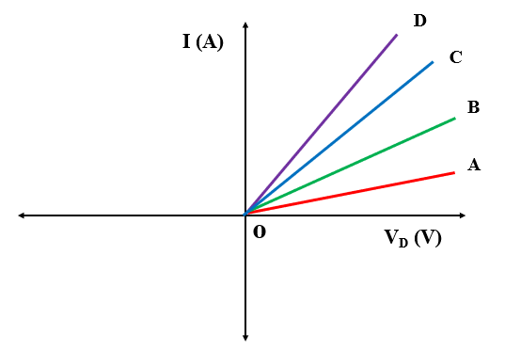(b) 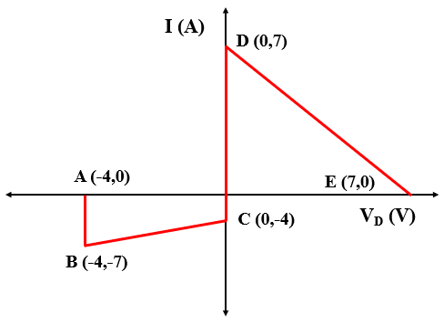

Ans: (a) |OA|<|OB|<|OC|<|OD|, (b) Slopes of AB and CD are equal(infinity). The DE slope is negative. However, the value of slope is higher than BC here. |BC|<|DE|<|AB|

* Find out the slope of the following curves



Answer: **Slope, |m|=**

|BC|= **=** =

|DE|= **=** =

|AB|= **=** = **∞**

## **Piecewise Linear Approximation**

Modeling non-linear devices accurately at each point of its I-V curve is quite difficult and time consuming due to the complexity of the equations representing the curve. Therefore, nonlinear functions are usually approximated by a series of linear segments that follow the tangent of the non-linear segment as can be seen from the following figure. This is called the piecewise-linear approximation of the function. Therefore a non-linear device can be represented as an equivalent linear device in each of the segments.

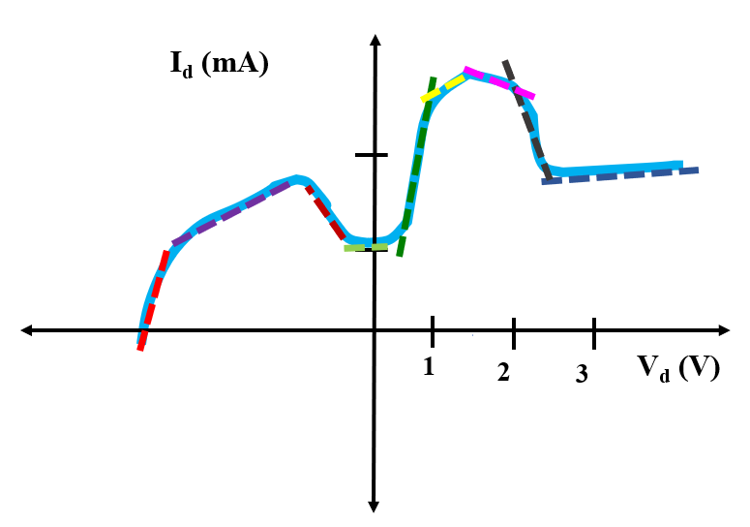

## **I-V Characteristics of Linear Device/Elements**

*[ The following figures summarize the graphs of “y= mx+c” functions with different values of c: 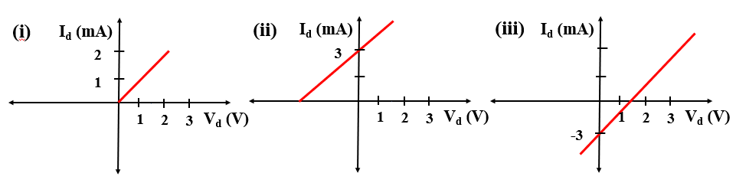*

*i. c=0, ii. c= $3$, iii. c= -3]*

#### **Single element Circuits**

##### **i. Resistors:**

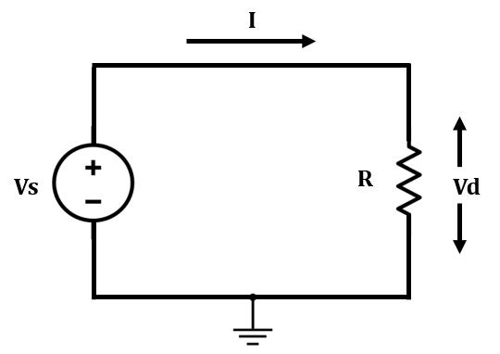

**Figure 4: A circuit with a single resistor**

The relationship between current, $Ir$ and voltage, $Vr$ in a resistor of value ‘ $R$’ is defined by the “**Ohm’s law**”:

$Vr=IrR$

$⇒Ir=\frac{Vr}{R}$

$⇒Ir=\frac{1}{R}. Vr+ 0$ (1)

This equation follows the form : ***y= mx+c.*** It can be seen that $Ir$ corresponds to ‘y’, $Vr$ corresponds to ‘x’ and ‘c’ is 0. Therefore, the slope, $|m|=|\frac{1}{R}|$

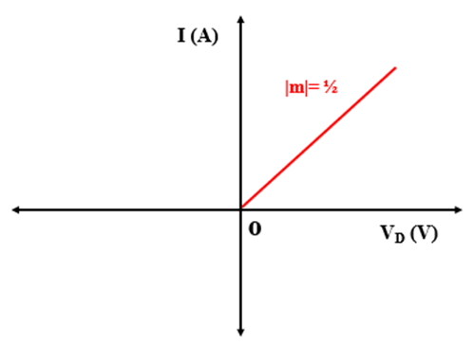

**Figure 5: I-V curve of a 2 resistor**

The I-V curve of a 2 $kΩ$ resistor is plotted in Figure 5. It is seen that the current increases linearly with voltage and the rate of change is the same at all points of the curve. The value of ‘c’ is 0, therefore, it goes through the origin.

The slope can be determined from the graph by:

**|m|=**

**|m|=**

**|m|=**

**|m|=**

Thus, ||= i.e. 2 $kΩ$. [ *Please keep the units of voltage and current in mind!* ]

From this, it is understood that a higher slope value of an I-V curve of a resistor indicates a lower resistance value and vice versa.

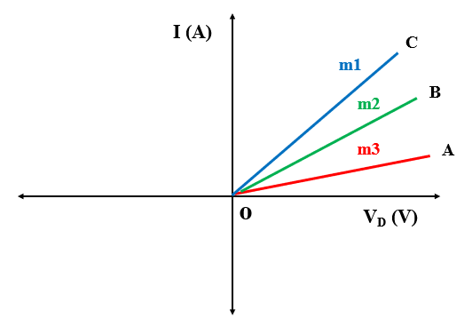

**Figure: I-V curves of different resistors**

In the Figure above, **m1>m2>m3.** Thus, **R1<R2<R3.**

* **This curve goes through the origin (0,0)**

##### **ii. Current Source:**

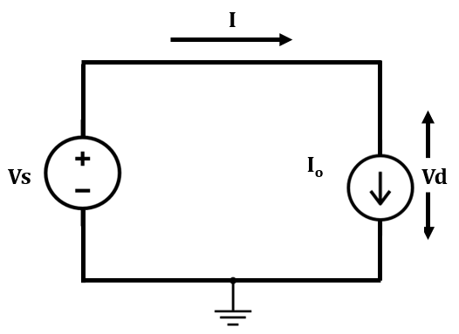

**Figure 6: A circuit with a single current source**

The value of current flow through a current source is fixed and thus does not change with

voltage. The equation is as follows:

***I= Io; where C is a constant***

The I-V curve of a Io=3 mA current source is plotted in Figure 7. It is seen that the current remains constant. The rate of change is the same at all points of the curve i.e. 0.

The slope can be determined from the graph by:

**|m|=**

**|m|=**

**|m|=**

**Figure 7** shows the I-V curves of current sources with different values (Io= 1 mA, -2 mA, -4 mA).

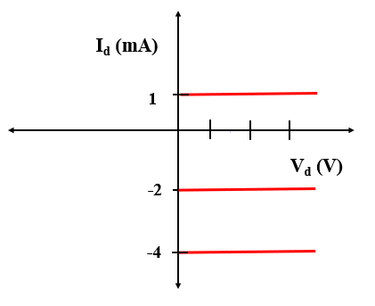

Figure 7: I-V curves of different current sources

* **This curve intersects the y axis at I=Io.**

#### **iii. Voltage Source:**

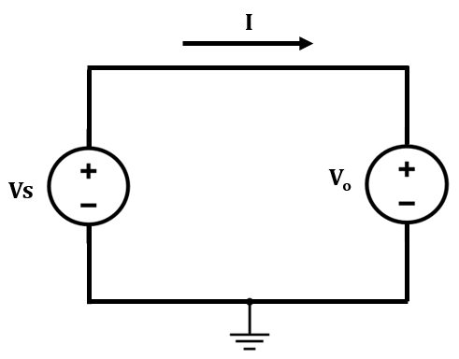

**Figure 8: A circuit with a single voltage source**

The value of voltage across a voltage source is fixed and thus does not change even if the current through the branch changes. The equation is as follows:

***Vo= C’; where C’ is a constant***

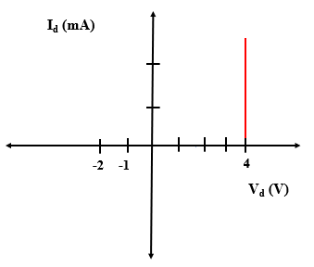

**Figure 9: I-V curve of a 4 V voltage source**

The I-V curve of a 4 V voltage source is plotted in Figure 9. It is seen that the voltage remains constant. The rate of change is the same at all points of the curve i.e. undetermined.

The slope from the graph:

**|m|=**

**|m|=**

**|m|= undetermined/ ∞**

**Figure 10** shows the I-V curves of voltage sources with different values ( Vo= 4 V, -2 V, -1V).

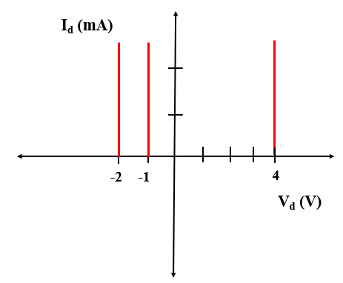

**Figure 10: I-V curves of different voltage sources**

* **This curve intersects the x axis at Vd=Vo.**

#### **Hybrid/ Compound Circuits**

*[ The following figures summarize source transformation:*

*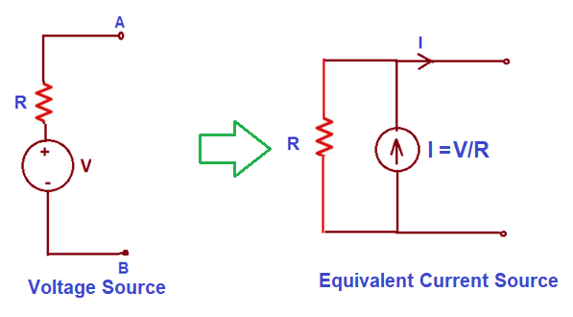]*

**i. Voltage Source in Series with a Resistor:**

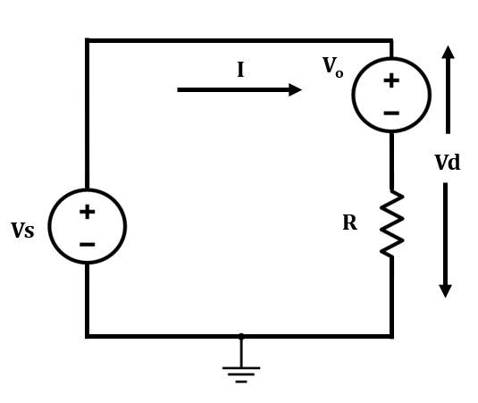

**Figure 11: A circuit with a resistor, R in series with a voltage Source, Vo**

Here, in the circuit of Figure 11, Vs is the source voltage, R is the value of the resistor and Vo is the value of the voltage source. By applying KVL, we can write-

$Vs-Vo= IR$

$⇒I=\frac{Vs-Vo}{R}$

$⇒I=\frac{1}{R}. Vs-\frac{Vo}{R}$ (2)

This equation follows the form : ***y= mx+c.*** It can be seen that $I$ corresponds to ‘y’, $Vs$ corresponds to ‘x’, the slope, $|m|=|\frac{1}{R}|$ and ‘c’ is $-\frac{Vo}{R}$.

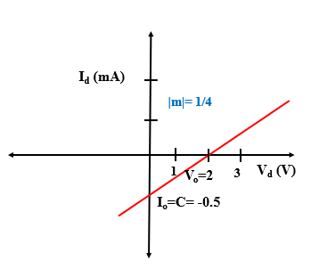

**Figure 12: I-V curve of a 4 $kΩ$ resistor in series with a 2 V voltage source**

The I-V curve of a 4 $kΩ$ resistor in series with a 2 V voltage source is plotted in Figure 12. It is seen that the current increases linearly with the source voltage, Vs and the rate of change is the same at all points of the curve.

The curve does not go through the origin (0,0) and cuts the y axis at ‘c’ i.e. $-\frac{Vo}{R}=-\frac{2}{4}mA=-\frac{1}{2}mA$.

The slope can be determined from the graph by:

**|m|=**

**|m|=**

**Or,**

**|m|**

Thus, ||= i.e. 0.25. [ *Please keep the units of voltage and current in mind!* ]

Now, it is seen that this curve also intersects the x axis at point “P”. What about the value of this point? At point “P”, the value of current, I is 0. Therefore, we can write-

$I=\frac{1}{R}. Vs-\frac{Vo}{R}$

$⇒0=\frac{1}{R}. Vs-\frac{Vo}{R}$

$⇒\frac{1}{R}. Vs=\frac{Vo }{R}$

$⇒Vs= Vo$

This means that at this point, the value of the source has become equal to the value of the voltage source which results in a “Zero” current flow.

**Figure 13** shows the I-V curves of voltage sources in series with resistors with different values of Vo and R.

i. Vo= 3V, R= 3 $kΩ$

ii. Vo= 3V, R= 4 $kΩ$

iii. Vo= 3V, R= 5 $kΩ$

iv. Vo= -3V, R= 3 $kΩ$

v. Vo= -2V, R= 3 $kΩ$

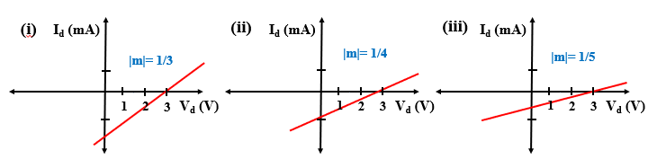

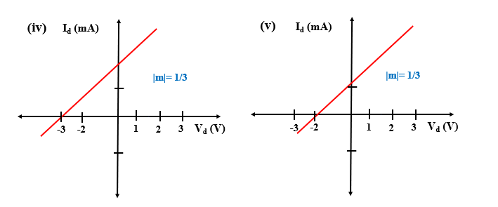

**Figure 13: I-V curves of voltage sources with resistance in series**

**\* The value of a resistor CAN NOT be Negative!**

##### **Practice Problems**

1. Calculate and Show ‘C’ and ‘Io’ in the figures

**[Hint: use $-\frac{Vo}{R}=Io$ =c]**

1. Draw the alternative circuit diagram, I-V curve and calculate the parameters with the following information:

i. Vo= 5V, m= 2 / $kΩ$

ii. Vo= 3.5 V, m= -2.5/ $kΩ$

iii. Vo= -5V, m= 5/ $kΩ$

**Solution:**

i. ||= i.e. $\frac{1}{2}$ $kΩ$, $c=-\frac{Vo}{R}$ = $-\frac{5}{0.5}mA=-2.5 mA$

ii. ||= i.e. $\frac{1}{2.5}$ $kΩ$, $c=-\frac{3.5}{0.4}mA=-8.75 mA$

iii. ||= i.e. $\frac{1}{5}$ $kΩ$, $c=-\frac{-5}{0.2}mA= 25 mA$

**Alternative Diagram:**

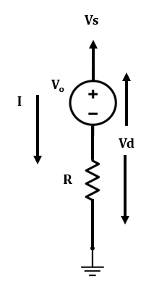

**I-V curve:**

* + **These curves intersect the x axis at Vo and y axis at $-\frac{Vo}{R}=Io$.**

#### **ii. Current source in Parallel with a Resistor:**

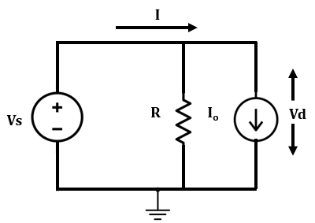

**Figure 14: A circuit with a resistor, R in parallel with a current source, Io**

Here, in the circuit of Figure 14, Vs is the source voltage, R is the value of the resistor and Io is the value of the voltage source. Assume that the total current is Is and the current through the resistor is, Ir. By applying KCL, we can write-

$Is= Io+Ir$

$⇒Is=\frac{Vo}{R}+Io$

$⇒Is=\frac{Vs}{R}+Io$

This equation follows the form : ***y= mx+c.*** It can be seen that $Is$ corresponds to ‘y’, $Vs$ corresponds to ‘x’, the slope, $|m|=|\frac{1}{R}|$ and ‘c’ is $Io$.

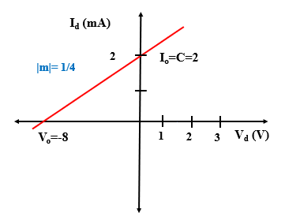

**Figure 15:** The I-V curve of a resistor in parallel with a current source

The I-V curve of a 4 $kΩ$ resistor in parallel with a 2 mA current source is plotted in Figure 15. It is seen that the current increases linearly with the source voltage, Vs and the rate of change is the same at all points of the curve.The slope can be determined from the graph by:

**|m|=**

**|m|=**

**Or,**

**|m|**

Thus, ||= i.e. 0.25. [ *Please keep the units of voltage and current in mind!* ]

The curve does not go through the origin (0,0) and cuts the y axis at ‘c’ i.e. $Io=2 mA$.

Now, it is seen that this curve also intersects the x axis at point “Q”. What about the value of this point? At point “Q”, the value of current, Is is 0. Therefore, we can write-

$0=\frac{Vs}{R}+Io$

$⇒Io=-\frac{Vs}{R}$

$⇒IoR=-Vs$

$⇒IoR=-Vo$

Here,Vo is the value of the voltage source in the equivalent circuit of Figure 14 with a Voltage source with a series resistance.

**Figure 16** shows the I-V curves of current sources in parallel with resistors with different values of Vo and R.

i. Io= 5 mA, R= 3 $kΩ$

ii. Io= 5 mA, R= 4 $kΩ$

iii. Io= 5 mA, R= 5 $kΩ$

iv.Io= -5 mA, R= 3 $kΩ$

v. Io= -4 mA, R= 3 $kΩ$

**\* The value of a resistor CAN NOT be Negative!**

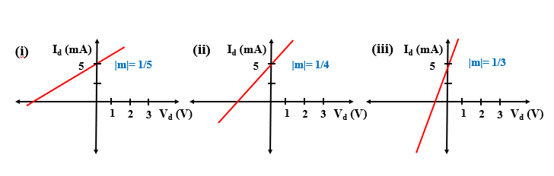

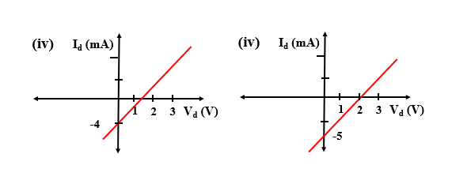

**Figure 16: I-V curves of current sources with resistance in parallel**

* + **These curves intersect the x axis at -Vo and y axis at Io.**

##### **Practice problems**

**1.** Calculate and Show ‘C’ and ‘Vo’ in the figures

**[Hint: Use $IoR=-Vo$]**

**2.** Draw the alternative circuit diagram with the equivalent linear model, I-V curve and calculate the parameters with the following information: Io= 5 mA, m= 2 $/kΩ$

**Solution:**

||= i.e. $\frac{1}{2}$ $kΩ$, $c=Io$ = $5 mA$, $Vo=-IoR=-2.5 V$

**Alternative diagram:**

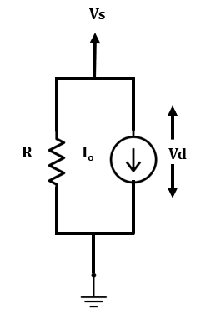

**I-V:** 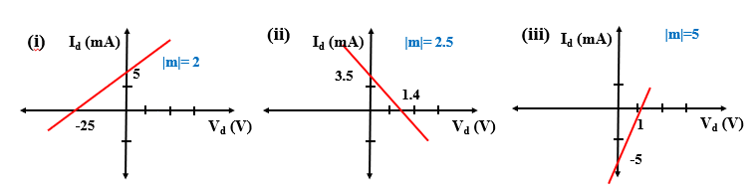

#### **Degenerate Elements**

**i. Open Circuit:**

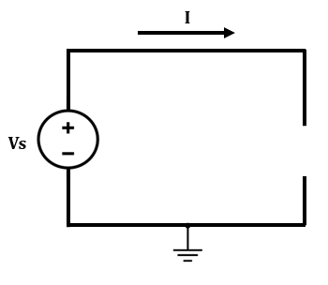

**Figure 17: A circuit with a Open circuit**

The value of current flow through a open circuit is 0 and does not change with

voltage. The equation is as follows:

***I= Io= 0 mA***

The I-V curve of an open circuit is plotted in Figure 18.

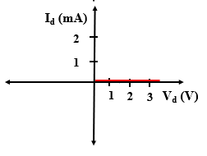

**Figure 18: I-V curve of Open circuit**

* **This curve falls upon the x axis.**

**ii. Short Circuit:**

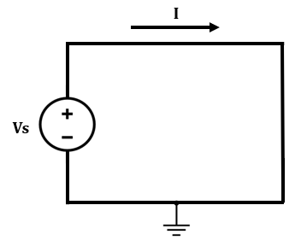

**Figure 19: A circuit with a Short circuit**

The value of voltage across a short circuit is 0 and does not change with current . The equation is as follows:

***V= Vo= 0 V***

The I-V curve of an open circuit is plotted in Figure 20.

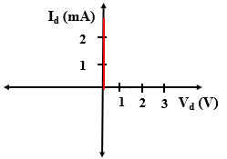

**Figure 20: I-V curve of a Short Circuit**

* **This curve falls upon the y axis.**

**Practice Problems**

1. A Voltage Source, Vo= 10 V in series with a resistor of R= 3 $kΩ$.

i. Write down the equation representing this curve

ii. Determine the unknown parameters

iii. Label the I-V curve

**Solution:**

i. y= mx+c

Or, I= m. Vs $-\frac{Vo}{R}$

ii. Vo= 10 V, R=3

**|m|**

Y axis intersection: c= $-\frac{Vo}{R}$ = $-\frac{10V}{3kΩ}=-\frac{10}{3}$ mA

X axis intersection: $Vo$ = 10 V

iii.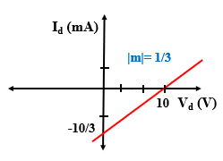

1. A Voltage Source, Vo= -10 V in series with a resistor of R= 3 $kΩ$.

i. Write down the equation representing this curve

ii. Determine the unknown parameters

iii. Label the I-V curve

**Solution:**

i. y= mx+c

Or, I= m. Vs $-\frac{Vo}{R}$

ii. Vo= 10 V, R=3

**|m|**

Y axis intersection: c= $-\frac{Vo}{R}$ = $-\frac{-10V}{3kΩ}=\frac{10}{3}$ mA

X axis intersection: $Vo$ = -10 V

iii. 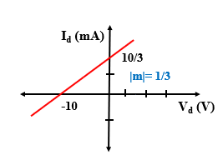

1. A Current Source, Io= 5 mA in parallel with a resistor of R= 5 $kΩ$.

i. Write down the equation representing this curve

ii. Determine the unknown parameters

iii. Label the I-V curve

**Solution:**

i. y= mx+c

Or,

ii. Vo= 10 V, R=5

**|m|**

Y axis intersection : c= $Io$ = 5 mA

X axis intersection: $IoR=-Vo$

Or, Vo= -5*5 V= -25V

iii. 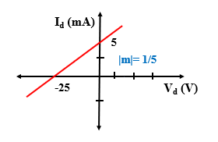

1. A Current Source, Io= -5 mA in parallel with a resistor of R= 5 $kΩ$.

i. Write down the equation representing this curve

ii. Determine the unknown parameters

iii. Label the I-V curve

**Solution:**

i. y= mx+c

Or,

ii. Vo= 10 V, R=5

**|m|**

Y axis intersection : c= $Io$ = -5 mA

X axis intersection: $IoR=-Vo$

Or, Vo= 5*5 V= 25V

iii. 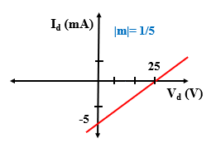

1. A Current Source, Io= 5 mA in parallel with a resistor. The slope of the curve is, m= -5 ${kΩ}^{-1}$.

i. Write down the equation representing this curve

ii. Determine the unknown parameters

iii. Label the I-V curve

**Solution:**

i. y= mx+c

Or, $Is=\frac{Vs}{R}+Io$

ii. Vo= 10 V, m= -5

**|R|**

Y axis intersection : c= $Io$ = 5 mA

X axis intersection: $IoR=-Vo$

Or, Vo= -5*5 V= -25V

1. A Voltage Source, Vo= -10 V in series with a resistor. The slope of the curve is, m= -3 ${kΩ}^{-1}$.

i. Write down the equation representing this curve

ii. Determine the unknown parameters

iii. Label the I-V curve

**Solution:**

i. y= mx+c

Or, I= m. Vs $-\frac{Vo}{R}$

ii. Vo= 10 V, m= -3 .

**|R|**

Y axis intersection: c= $-\frac{Vo}{R}$ = $-\frac{-10V}{3kΩ}=\frac{10}{3}$ mA

X axis intersection: $Vo$ = -10 V